**Blog writing date: 17 May 2025**

Blog Link: <https://staffordgolfstore.com/best-golf-club-heads-2025-how-boost-swing-speed-fast/>

[Keyword Research For https://staffordgolfstore.com.xlsx](https://docs.google.com/spreadsheets/d/1FWXOh4UiMqRBtNyZKnqyH7xKhHx5wEaJ/edit?gid=920018830#gid=920018830)

**Page Title:** Best Golf Club Heads 2025: How Boost Swing Speed Fast?

**Meta Description:** Want faster swings in 2025? Explore the top golf club heads designed for power, precision, and peak speed gains.

# H1: Best Golf Club Heads 2025: How Boost Swing Speed Fast?

## H2: My Take: Small Head Change, Big Distance Gains

Let me start with a personal truth — upgrading my golf club head in 2024 made a bigger difference than expected. I went from struggling to hit 220 yards to occasionally reaching 250+. The difference wasn’t just in the swing, but in the tech inside the head, lighter materials, optimized aerodynamics, and a face design that gave me more forgiveness and speed.

In 2025, golf brands are pushing boundaries with AI-designed faces, adjustable hosels, and multi-material constructions that help you swing faster without changing your swing. Whether you’re a high handicapper or a weekend warrior, the right club head can add serious speed and distance to your game.

## H2: What Are Golf Club Heads?

The golf club head is the part of the club that hits the ball. It plays a significant role in how far the ball goes, how straight it flies, and how easy it is to control your shot. Every type of club — from drivers to irons, wedges to putters — has a specially designed head to serve a specific purpose.

For example, driver heads are large and built for distance, while wedge heads are intended for short, high-spin shots. The club head’s design, shape, and material (like titanium or forged steel) all affect how the ball reacts. That’s why choosing the right golf club head is essential for improving your game.

Types of Golf Club Heads

Golf club heads come in different shapes and designs, each tailored to a specific part of the game:

Driver Heads: These are the largest heads, designed for maximum distance off the tee. They usually feature lightweight materials and low-spin technology to help players launch the ball far with less effort.

Fairway Wood Heads: Slightly smaller than drivers, these are great for long shots from the fairway or tee. They offer versatility and a more forgiving strike.

Hybrid Club Heads: A mix of iron and wood design, hybrids are easier to hit from rough or tight lies and offer higher launch and better control.

Iron Heads: These provide precision for mid to short-range shots. Forged irons give a better feel, while cast irons are more forgiving.

Wedge Heads: Built for high spin and short game control, wedges have specialized grooves for stopping power.

Putter Heads: Designed for accuracy and feel, used on the green.

From adjustable driver heads to high-MOI putters, the design affects launch angle, forgiveness, and overall performance.

Why Golf Club Heads Matter for Your Swing Speed

If you want to boost your swing speed, upgrading your golf club head could make a bigger difference than tweaking your swing. Modern club heads use lightweight materials like carbon fiber and titanium to reduce drag and help you swing faster. A higher COR (Coefficient of Restitution) increases energy transfer, giving you more ball speed with less effort.

Brands like Ping and TaylorMade have perfected aerodynamic shapes in models like the G430 and Qi10, inspired by the demands of tour pros like Bryson DeChambeau and Rory McIlroy — now available to every golfer.

## H2: Top Features to Look for in Golf Club Heads 2025

The latest golf club heads in 2025 are smarter, faster, and more forgiving than ever. Here are the key features to look for — and how they can help you play better golf:

| **Feature** | **What It Does** | **Why It Matters for You** |
| --- | --- | --- |
| Adjustable Weights | Move small weights in the head to change balance | Helps you control your ball flight — you can hit straighter or curve the ball more based on how you set it up |
| Loft & Face Angle Settings | Change the angle of the club face and loft using a wrench | You can fine-tune your launch height and spin to fit your swing speed or playing conditions |
| Low Center of Gravity (CG) | Designers move weight lower in the club head | Makes it easier to get the ball in the air and reduces unwanted spin — perfect for extra carry distance |
| High MOI (Moment of Inertia) | Resistance to twisting when you miss the sweet spot | Means more forgiveness on off-center hits — your bad swings still go fairly straight and far |
| Titanium & Carbon Fiber Materials | Advanced lightweight materials used in premium heads | Lets brands like Callaway and TaylorMade make heads that are both strong and light — more swing speed without more effort |
| Speed Tech (Twist Face, Jailbreak, AI Face) | Smart face designs using AI and tested shaping | Keeps ball speed high even on mis-hits — so you get better distance even when your swing isn’t perfect |

## H2: Best Golf Club Heads for Distance (2025 Edition)

The right driver’s head can make a massive difference when maximizing distance, especially with the cutting-edge technology in 2025. Three standout models combine high COR, aerodynamic shaping, and innovative materials like titanium and carbon fiber to help you gain serious yards.

Callaway Paradym Ai Smoke

Designed using AI face optimization, this driver head delivers maximum forgiveness and ball speed across the face. It’s an excellent pick for mid-to-low handicappers seeking powerful, consistent drives.

TaylorMade Qi10 Max

This club head is perfect for players with slower swing speeds who want to add effortless distance. It features a massive sweet spot, Twist Face technology, and an adjustable hosel.

Product picture

Ping G430 Max

Known for its high MOI and low spin rate, this head offers incredible stability and control without sacrificing yardage.

Product picture

Cobra DARKSPEED X

Ultra-aerodynamic head and PWR-Bridge weighting boost carry for moderate swing tempos.

Product picture

Titleist TSR2

Perfect blend of speed and feel with a clean, confidence-inspiring look at address.

Product picture

PXG 0311 Black Ops

Built for raw power with adjustable weighting and a thin forged face.

Pro Tip: Use a launch monitor like TrackMan or GCQuad to test these heads and find which gives you the most speed and carry distance.

Product picture

## H2: Best Golf Club Heads for Control and Accuracy

Control and accuracy matter more than raw distance when hitting fairways consistently. In 2025, several golf club heads are designed with advanced technologies that help golfers keep the ball on target, especially when not swinging perfectly.

The Titleist TSR2 stands out for its clean impact feel and superb stability, even on toe or heel strikes. Its optimized MOI (moment of inertia) ensures straighter ball flights. The Cobra Aerojet LS offers precise trajectory control thanks to its low-spin design and adjustable face angle. For players who want to shape shots, the Mizuno ST-Z 230 blends forgiveness with workability — ideal for mid-handicappers improving their game.

These club heads feature innovations like internal weighting systems, low CG, and face technologies that improve directional control, making them perfect for players focused on accuracy over distance.

How to Match a Golf Head with Your Swing Speed

Every golfer’s speed is different, and choosing the right golf club head for your speed can make a big difference in distance and accuracy.

Slow swing speed (under 85 mph): You’ll benefit from lightweight club heads like the TaylorMade Qi10 Max or Cobra AIR-X. These help generate more clubhead speed with less effort, improving launch and carry distance.

Moderate swing speed (85–100 mph): Opt for mid-weight, adjustable driver heads like the Ping G430 Max or Callaway Paradym X. These offer adjustable face angles and loft settings to fine-tune your launch conditions.

Fast swing speed (100+ mph): Go for low-spin, compact driver heads like the Callaway Ai Smoke Triple Diamond or Titleist TSR4, designed to reduce spin and increase control at high velocities.

For best results, get a custom fitting session using a launch monitor such as TrackMan or GCQuad. Most golf retailers, like Club Champion and Golf Galaxy, offer professional fittings to match your swing speed with the perfect club head.

## H2: Top Rated Driver Heads by Skill Level

Choosing the right driver head based on your skill level can greatly improve your performance. Here’s a breakdown of top-rated driver heads in 2025 for every type of golfer:

| **Skill Level** | **Recommended Head** | **Key Features** | **Learn More** |
| --- | --- | --- | --- |
| Beginner | Ping G430 Max | Extreme forgiveness, large sweet spot, easy-to-launch with high MOI | Ping G430 Review – Golf Monthly |
| Intermediate | Callaway Paradym X | Balanced distance and forgiveness, adjustable face angle, high COR, Jailbreak AI face technology | Callaway Paradym Review – GolfWRX |
| Low Handicap | Titleist TSR3 | Low-spin, tour-preferred shape, adjustable SureFit hosel for workability and precision | Titleist TSR3 Review – MyGolfSpy |
| Tour-Level | TaylorMade Qi10 LS | Compact 450cc head, low spin design, Twist Face, Speed Pocket, and carbon sole for ultimate control | TaylorMade Qi10 LS Review – Golf Digest |

Tour professionals like Rory McIlroy and Tiger Woods rely on tech like AI-designed faces, Speed Pocket, and Jailbreak bars to fine-tune their performance — and now, that same innovation is accessible to all levels of golfers.

### H3: Golf Club Head Fitting: Why It's a Game-Changer

A club head fitting session isn’t just for pros — it’s the fastest way to improve your game.

Adjust launch angle, spin rate, and trajectory

Discover ideal MOI, CG, and loft

Brands like PXG and Titleist offer fitting tools on their sites

Most fittings last 45-60 minutes and can be done at your local pro shop or golf retailer.

Common Myths About Golf Club Heads

Myth: Heavier heads hit farther – Not always. Modern lightweight heads increase club speed, boosting distance.

Myth: Only pros need advanced tech – False! Features like adjustable hosels help beginners, too.

Myth: Cast heads are worse than forged—not necessarily. Cast heads can offer more forgiveness and are budget-friendly.

Best Budget Golf Club Heads That Perform

You don’t need to spend $500+ to get top-tier performance. Several budget-friendly golf club heads under $300 still deliver excellent distance, control, and forgiveness, especially with 2023–2024 models seeing price drops as newer tech arrives. Here are three standouts:

Mizuno ST-X 230 – Known for its smooth feel and draw-biased design, this driver head helps reduce slices and adds forgiveness, making it ideal for mid to high handicappers.

Cobra Aerojet – Packed with aerodynamic shaping and PWR-Bridge technology, this club head delivers high launch and good ball speed. A solid pick for improving distance without overspending.

TaylorMade SIM2 – Although an older model, it still holds up with its Twist Face technology and high MOI, giving players more consistent shots.

These heads are perfect for casual golfers or those upgrading on a budget. They offer real performance without the premium price tag.

Heading Tag Structure:

H1: Best Golf Club Heads 2025: How Boost Swing Speed Fast?

H2: My Take: Small Head Change, Big Distance Gains

H3: What Are Golf Club Heads?

H3: Types of Golf Club Heads

H2: Why Golf Club Heads Matter for Your Swing Speed

H3: Top Features to Look for in Golf Club Heads 2025

H3: Best Golf Club Heads for Distance (2025 Edition)

H4: Callaway Paradym Ai Smoke

H4: TaylorMade Qi10 Max

H4: Ping G430 Max

H4: Cobra DARKSPEED X

H4: Titleist TSR2

H4: PXG 0311 Black Ops

H2: Best Golf Club Heads for Control and Accuracy

H3: How to Match a Golf Head with Your Swing Speed

H2: Top Rated Driver Heads by Skill Level

H3: Golf Club Head Fitting: Why It's a Game-Changer

H4: Common Myths About Golf Club Heads

H2: Best Budget Golf Club Heads That Perform

H2: Golf Club Head Maintenance & Longevity Tips

H3: Comparing Forged vs Cast Club Heads

H4: Forged Club Heads

H4: Cast Club Heads

H4: Which to Choose?

H2: Newest Golf Club Head Technologies in 2025

H3: Golf Club Heads for Women and Seniors

H3: Environmentally Friendly Golf Heads

H3: FAQs

H3: Final Thoughts

H4: Title text example

H2: 12 thoughts on “Best Golf Club Heads 2025: How Boost Swing Speed Fast?”

**N:B- Website Login expired because of finished this Job**

Now:

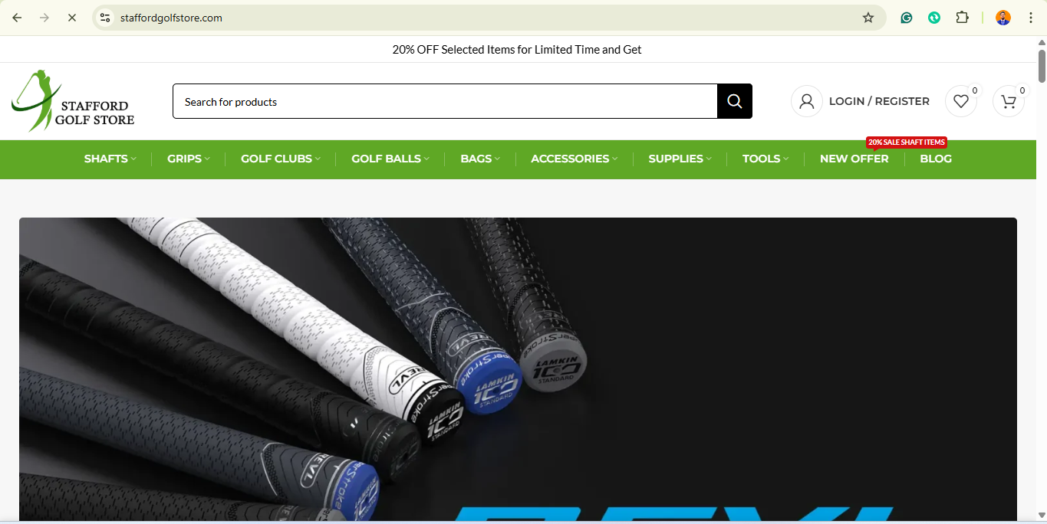

Previous:

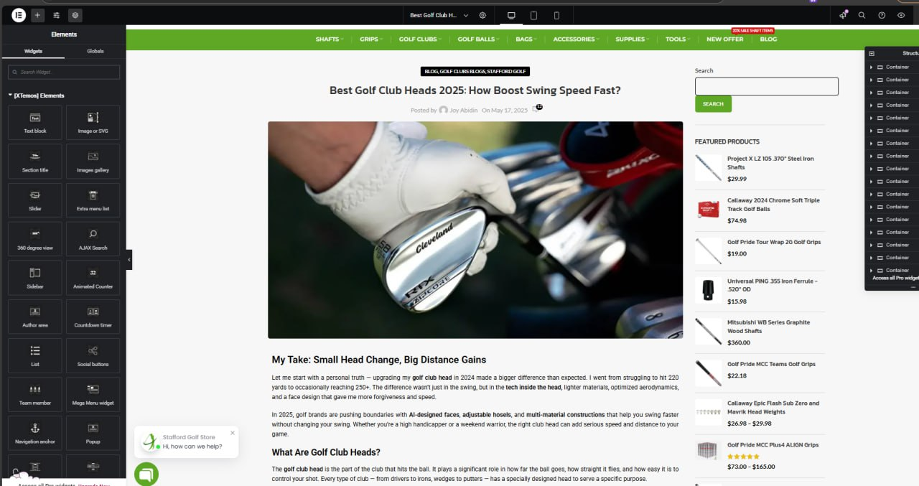

**………………………………………………………………………………………………**

**Thank you.**

**Md Juel Shakh**

**SEO Specialist**